***Character Counts***

Months in review: 2023 – 2024

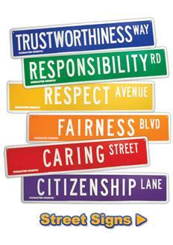

August, September: **RESPONSIBILITY**

October/November: **RESPECT**

December/January: **TRUSTWORTHINESS**

February: **CARING**

March: **FAIRNESS**

April: **CITIZENSHIP**

May: **ALL TRAITS**

Last updated 08/31/2022 NV